Supplementary File
Supplemental Figure 1. Illustration of P-V loop analysis by quadrants. A) Four key events in the cardiac cycle are defined by the pressure gradient (i.e., dP/dt max and dP/dt min). i) Aortic valve opening (turquoise), ii) End of systole (red), iii) End of isovolumetric relaxation (pink), and iv) end of diastole (purple), B) Four key elements of the cardiac cycle derived from the timepoints defined in Figure 1A. This includes the i) Ejection Phase (blue), ii) Isovolumetric Relaxation (red), iii) Left Ventricular filling (purple) and iv) Isovolumetric contraction (turquoise).
A.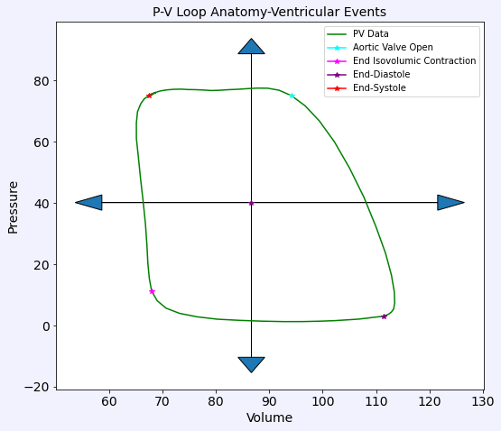 | B.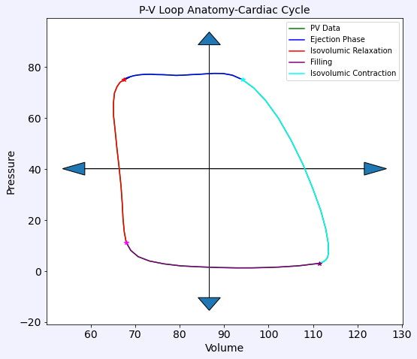

Supplemental Figure 2. Sample Algorithm Results. A) Sample of Pre-Screening Report, B) Sample Parameter Histogram, C) Sample Parameter Beat-to-Beat Report, D) Sample Parameter Time Variation Report
A.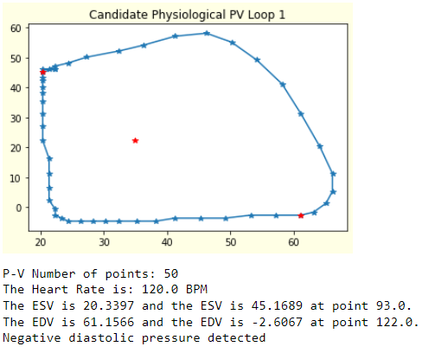 | B.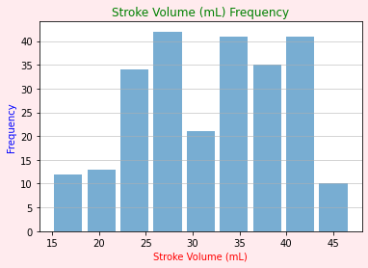
C.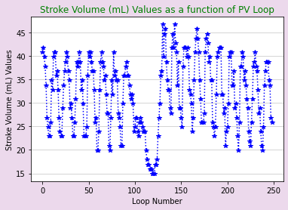 | D.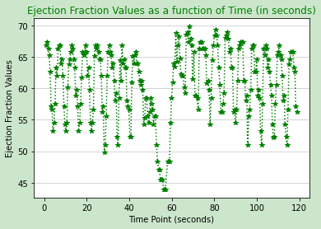

Supplemental Table 1. Load-Independent Curve Fits. To address varying curve fits for the EDPVR and ESPVR our code has incorporated six possible curve fits for both.

EDPVR Curve Fits | ESPVR Curve Fits
$$P=A+Be^{αV}$$  $$P=Ce^{βV}$$  $$P=D+aV^{3}$$  $$P=a_{0}+a_{1}V+a_{2}V^{2}+a_{3}V^{3}$$  $$P=b+cV^{γ}$$  $$P=dV^{δ}$$ | $$P=a_{1}V+a_{0}$$  $$P=a_{1}V+a_{0}, where P\left(V_{0,lin}\right)=0$$  $$P=a_{2}V^{2}+a_{2}V+a_{0}$$  $$P=a_{2}V^{2}+a_{2}V+a_{0}, where P\left(V_{0,quad}\right)=0$$  $$P=\ln\left(\frac{V}{V_{0}}\right){\left(α+βV\right)}^{-1}$$  $$P=\ln\left(\frac{V}{V_{0}}\right){\left(α+βV\right)}^{-1}, where P\left(V_{0,log}\right)=0$$

Supplemental Figure 3. Sample Ensemble Average Output. Sample of ensemble average super-imposed on pre-IVCO data, creating an idealized representation of the chosen time point.
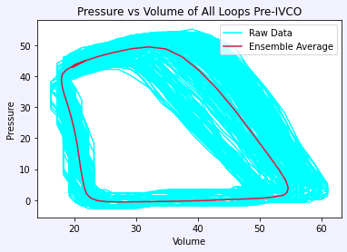

Supplemental Figure 4. Ensemble Average Outputs For Pre-IVC, During-IVC, Post-IVC and the Cumulative. The ensemble average is able to account for P-V loop variability and creates a singular representation for a certain phase as opposed to selecting a loop which may have been impacted by a respiration artifact, allowing for comparison of P-V events pre-, during- and post-IVCO to be reasonably compared.

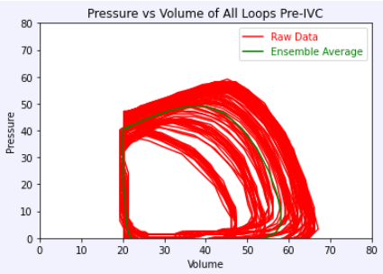  A: Ensemble Average Super-imposed to Data Sample Pre-IVCO | 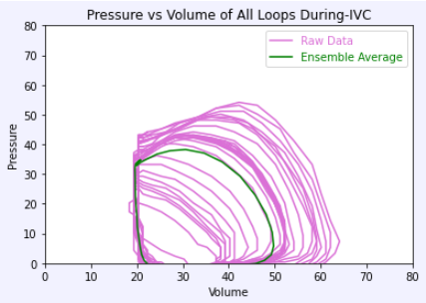  B: Ensemble Average Super-imposed to Data Sample During-IVC
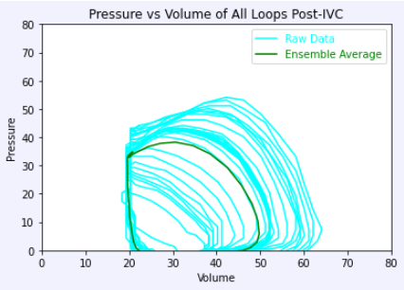  C: Ensemble Average Super-imposed to Data Sample Post-IVC | 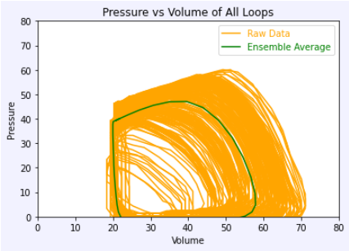  D: Ensemble Average Super-imposed to Data Sample Pre-, During- and Post-IVCO

Supplemental Table 2. Summary Curve Fit Parameters for EDPVR During IVCO. Mean and standard deviations for each parameter at baseline (T0), end of hemorrhage (T30) and at the end of intervention (T74).

Supplemental Table 3A. Summary of Control Group Cardiac Metrics. Mean and standard deviations are reported at each time point and pre-IVCO, during IVCO and post-IVCO.

 | T0  Pre-IVCO | T0 During IVCO | T0  Post-IVCO | T30  Pre- IVCO | T30  During IVCO | T30  Post- IVCO | T74  Pre- IVCO | T74  During IVCO | T74  Post- IVCO
Stroke Work (mmHg*mL) | 3300.8 ± 651.9 | 1973.6 ± 681.3 | 3190.5 ± 619.8 | 1451.5 ± 636.3 | 742.5 ± 344.3 | 1686.3 ± 718.4 | 4226.4 ± 801.8 | 2107.8 ± 653.2 | 4152.3 ± 1103.7
Stroke Volume (mL) | 44.6 ± 10.8 | 35.5 ± 10.1 | 43.7 ± 11.8 | 38.6 ± 10.9 | 25.3 ± 7.6 | 41.1 ± 12.2 | 55.9 ± 9.2 | 41.8 ± 4.4 | 51.7 ± 11.0
Ejection Fraction (%) | 42.2 ± 10.9 | 47.6 ± 13.7 | 41.9 ± 12.1 | 59.0 ± 10.6 | 49.5 ± 8.5 | 61.7 ± 9.7 | 53.8 ± 5.9 | 54.4 ± 6.5 | 51.9 ± 8.0
Heart Rate (bpm) | 91.3 ± 19.5 | 92.4 ± 19.6 | 91.9 ± 20.2 | 127.7 ± 34.6 | 123.9 ± 29.6 | 119.5 ± 26.0 | 136.5 ± 19.9 | 136.1 ± 21.6 | 133.0 ± 24.1
Cardiac Output (L/min) | 4.0 ± 1.1 | 3.3 ± 1.1 | 4.0 ± 1.2 | 5.1 ± 2.5 | 3.3 ± 1.7 | 5.1 ± 2.4 | 7.7 ± 1.9 | 5.7 ± 0.9 | 6.9 ± 1.9
Arterial Elastance (mmHg/mL) | 1.8 ± 0.5 | 1.7 ± 0.4 | 1.9 ± 0.8 | 1.1 ± 0.4 | 1.4 ± 0.4 | 1.0 ± 0.3 | 1.4 ± 0.5 | 1.4 ± 0.4 | 1.5 ± 0.5
ESV (mL) | 63.3 ± 17.7 | 42.9 ± 20.4 | 63.0 ± 19.2 | 26.6 ± 6.4 | 25.5 ± 5.8 | 25.2 ± 5.5 | 48.4 ± 5.9 | 34.6 ± 8.3 | 48.6 ± 9.5
ESP (mmHg) | 74.9 ± 7.5 | 56.7 ± 5.7 | 72.7 ± 8.0 | 37.4 ± 7.7 | 32.2 ± 5.4 | 39.0 ± 7.7 | 71.6 ± 15.8 | 53.4 ± 10.5 | 72.9 ± 14.5
EDV (mL) | 107.9 ± 13.1 | 78.3 ± 22.2 | 106.7 ± 13.7 | 65.2 ± 11.1 | 50.7 ± 10.5 | 66.3 ± 13.4 | 104.3 ± 9.3 | 76.4 ± 8.8 | 100.3 ± 11.5
EDP (mmHg) | 6.7 ± 2.3 | 4.8 ± 3.6 | 6.4 ± 2.7 | 4.4 ± 2 | 3.8 ± 2.4 | 3.2 ± 2.4 | 7.2 ± 2.0 | 5.6 ± 0.8 | 4.2 ± 1.6

Supplemental Table 3B. Summary of REBOA Group Cardiac Metrics. Mean and standard deviations are reported at each time point and pre-IVCO, during IVCO and post-IVCO.

 | T0  Pre-IVCO | T0 During IVCO | T0  Post-IVCO | T30  Pre- IVCO | T30  During IVCO | T30  Post- IVCO | T74  Pre- IVCO | T74  During IVCO | T74  Post- IVCO
Stroke Work (mmHg*mL) | 3647.9 ± 1097.7 | 1763.9 ± 636.4 | 3447.8 ± 1081.4 | 1823.5 ± 460.3 | 414.3 ± 151.2 | 1908.1 ± 423.9 | 9327.8 ± 3237.8 | 5680.8 ± 4349.5 | 8785.4 ± 3016.3
Stroke Volume (mL) | 50.3 ± 20.7 | 36.1 ± 11.7 | 51.7 ± 18.7 | 46.2 ± 14.1 | 22.8 ± 5.1 | 47.9 ± 14.3 | 59.4 ± 33.2 | 49.2 ± 30.9 | 61.3 ± 29.6
Ejection Fraction (%) | 41.8 ± 9.6 | 45.2 ± 8.7 | 45.6 ± 7.4 | 60.2 ± 8.4 | 39.5 ± 2.8 | 62.5 ± 5.5 | 45.2 ± 13.4 | 51.3 ± 14.9 | 49.5 ± 11.0
Heart Rate (bpm) | 89.8 ± 14.6 | 92.9 ± 19.5 | 88.9 ± 13.5 | 117.5 ± 23.3 | 113.2 ± 19.2 | 111.2 ± 22.3 | 163.4 ± 16.5 | 154.9 ± 34.1 | 157.6 ± 17.4
Cardiac Output (L/min) | 4.8 ± 2.9 | 3.5 ± 1.7 | 4.8 ± 2.6 | 5.5 ± 2.3 | 2.6 ± 0.9 | 5.4 ± 2.2 | 9.7 ± 5.6 | 7.8 ± 5.4 | 9.6 ± 4.8
Arterial Elastance (mmHg/mL) | 1.7 ± 0.6 | 1.7 ± 0.6 | 1.4 ± 0.4 | 1.0 ± 0.4 | 1.4 ± 0.8 | 0.9 ± 0.4 | 3.9 ± 2.0 | 2.7 ± 1.1 | 3.0 ± 1.7
ESV (mL) | 68.4 ± 15.7 | 44.3 ± 7.1 | 61.7 ± 17.0 | 30.9 ± 11.0 | 35.6 ± 12.2 | 29.0 ± 9.7 | 68.9 ± 21.1 | 43.2 ± 10.9 | 60.6 ± 14.5
ESP (mmHg) | 72.1 ± 3.7 | 55.3 ± 8.8 | 66.2 ± 7.0 | 39.3 ± 7.8 | 28.6 ± 7.5 | 39.1 ± 8.7 | 173.8 ± 18.9 | 108.9 ± 42.2 | 143.0 ± 28.8
EDV (mL) | 118.7 ± 27.0 | 80.4 ± 11.8 | 113.4 ± 29.6 | 77.1 ± 21.3 | 58.4 ± 17.3 | 76.9 ± 22.0 | 128.3 ± 43.3 | 92.4 ± 33.7 | 121.9 ± 36.1
EDP (mmHg) | 6.6 ± 3.5 | 4.8 ± 3.7 | 6.1 ± 2.8 | 2.4 ± 1.8 | 3.5 ± 2.2 | 2.3 ± 1.6 | 6.4 ± 1.6 | 5.3 ± 2.8 | 5.7 ± 1.9

Supplemental Table 3C. Summary of EVAC Group Cardiac Metrics. Mean and standard deviations are reported at each time point and pre-IVCO, during IVCO and post-IVCO.

 | T0  Pre-IVCO | T0 During IVCO | T0  Post-IVCO | T30  Pre- IVCO | T30  During IVCO | T30  Post- IVCO | T74  Pre- IVCO | T74  During IVCO | T74  Post- IVCO
Stroke Work (mmHg*mL) | 3201.4 ± 744.0 | 1994.0 ± 754.2 | 3132.3 ± 792.3 | 1840.7 ± 342.1 | 1236.4 ± 449.1 | 2530.2 ± 641.4 | 4771.3 ± 870.8 | 3017.5 ± 1454.4 | 4621.4 ± 871.9
Stroke Volume (mL) | 42.9 ± 14.6 | 24.8 ± 5.1 | 42.7 ± 15.2 | 39.2 ± 5.8 | 29.5 ± 5.4 | 43.6 ± 9.3 | 34.2 ± 0.9 | 28.0 ± 4.7 | 34.3 ± 4.4
Ejection Fraction (%) | 44.5 ± 12.9 | 38.5 ± 12.0 | 44.9 ± 13.8 | 62.2 ± 8.0 | 55.2 ± 10 | 64.3 ± 7.0 | 39.0 ± 6.08 | 41.1 ± 8.3 | 40.8 ± 7.7
Heart Rate (bpm) | 88.5 ± 18.9 | 86.0 ± 22.2 | 85.5 ± 13.4 | 135.4 ± 31.1 | 133.7 ± 29.4 | 118.6 ± 21.8 | 135.05 ± 27.78 | 130.2 ± 30.4 | 135.4 ± 26.4
Cardiac Output (L/min) | 3.8 ± 1.5 | 2.1 ± 0.4 | 3.7 ± 1.5 | 5.4 ± 1.8 | 3.9 ± 0.8 | 5.3 ± 1.8 | 4.6 ± 0.9 | 3.6 ± 0.9 | 4.6 ± 1.0
Arterial Elastance (mmHg/mL) | 2.0 ± 0.8 | 2.9 ± 0.8 | 2.0 ± 0.8 | 1.2 ± 0.3 | 1.5 ± 0.3 | 1.3 ± 0.4 | 4.07 ± 0.69 | 3.6 ± 0.8 | 4.0 ± 1.3
ESV (mL) | 55.3 ± 21.4 | 42.3 ± 17.9 | 54.2 ± 22.0 | 24.8 ± 8.7 | 24.2 ± 7.7 | 24.8 ± 8.1 | 55.65 ± 15.96 | 41.7 ± 11.1 | 51.9 ± 16.4
ESP (mmHg) | 76.1 ± 5.1 | 64.8 ± 11.5 | 73.4 ± 7.5 | 46.7 ± 6.5 | 42.0 ± 7.3 | 53.4 ± 11.2 | 134.62 ± 22.43 | 99.3 ± 25.1 | 123.8 ± 21.4
EDV (mL) | 98.2 ± 22.8 | 67.1 ± 18.8 | 96.9 ± 22.4 | 64.0 ± 11.7 | 53.8 ± 7.8 | 68.4 ± 14.8 | 89.8 ± 15.69 | 69.7 ± 9.3 | 86.2 ± 16.4
EDP (mmHg) | 7.0 ± 3.4 | 4.5 ± 3.7 | 6.9 ± 3.5 | 5.1 ± 5.2 | 3.7 ± 4.2 | 2.9 ± 3.1 | 7.46 ± 4.04 | 5.1 ± 3.3 | 6.0 ± 4.6

